Use Firefox soap client tester->Advanced Access.

<http://localhost:8181/ws/countries.wsdl>

Get

Past Raw Request body:

<soapenv:Envelope xmlns:soapenv="http://schemas.xmlsoap.org/soap/envelope/"

xmlns:gs="http://spring.io/guides/gs-producing-web-service">

<soapenv:Header/>

<soapenv:Body>

<gs:getCountryRequest>

<gs:name>Spain</gs:name>

</gs:getCountryRequest>

</soapenv:Body>

</soapenv:Envelope>

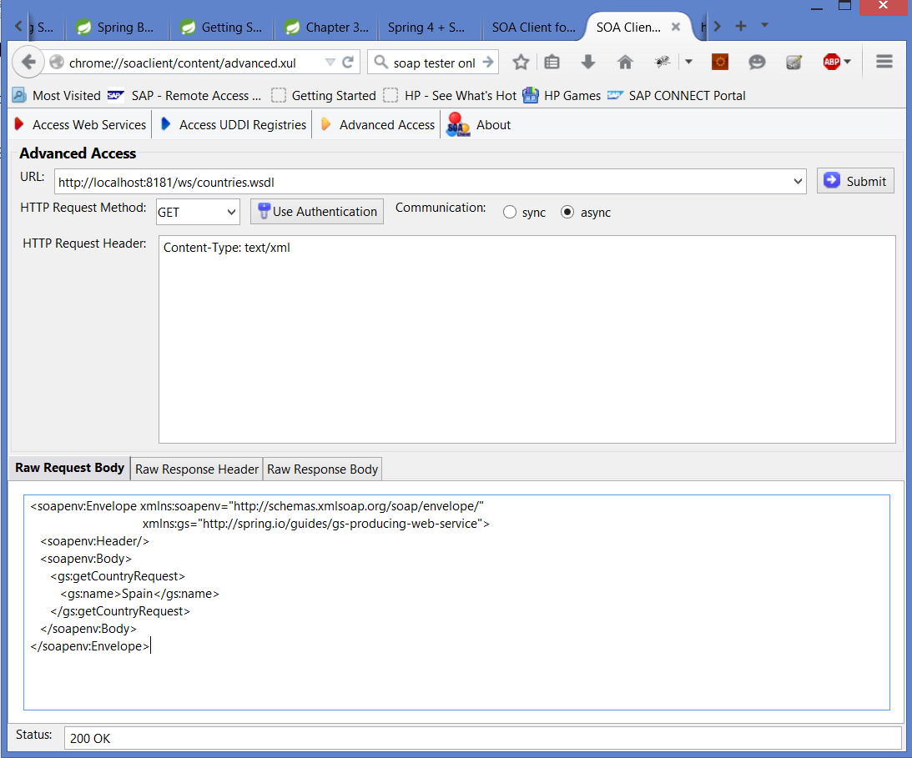

Click Submit and click Raw Response body. See the result:

<?xml version="1.0" encoding="UTF-8" standalone="no"?><wsdl:definitions xmlns:wsdl="http://schemas.xmlsoap.org/wsdl/" xmlns:sch="http://spring.io/guides/gs-producing-web-service" xmlns:soap="http://schemas.xmlsoap.org/wsdl/soap/" xmlns:tns="http://spring.io/guides/gs-producing-web-service" targetNamespace="http://spring.io/guides/gs-producing-web-service">

<wsdl:types>

<xs:schema xmlns:xs="http://www.w3.org/2001/XMLSchema" elementFormDefault="qualified" targetNamespace="http://spring.io/guides/gs-producing-web-service">

<xs:element name="getCountryRequest">

<xs:complexType>

<xs:sequence>

<xs:element name="name" type="xs:string"/>

</xs:sequence>

</xs:complexType>

</xs:element>

<xs:element name="getCountryResponse">

<xs:complexType>

<xs:sequence>

<xs:element name="country" type="tns:country"/>

</xs:sequence>

</xs:complexType>

</xs:element>

<xs:complexType name="country">

<xs:sequence>

<xs:element name="name" type="xs:string"/>

<xs:element name="population" type="xs:int"/>

<xs:element name="capital" type="xs:string"/>

<xs:element name="currency" type="tns:currency"/>

</xs:sequence>

</xs:complexType>

<xs:simpleType name="currency">

<xs:restriction base="xs:string">

<xs:enumeration value="GBP"/>

<xs:enumeration value="EUR"/>

<xs:enumeration value="PLN"/>

</xs:restriction>

</xs:simpleType>

</xs:schema>

</wsdl:types>

<wsdl:message name="getCountryRequest">

<wsdl:part element="tns:getCountryRequest" name="getCountryRequest">

</wsdl:part>

</wsdl:message>

<wsdl:message name="getCountryResponse">

<wsdl:part element="tns:getCountryResponse" name="getCountryResponse">

</wsdl:part>

</wsdl:message>

<wsdl:portType name="CountriesPort">

<wsdl:operation name="getCountry">

<wsdl:input message="tns:getCountryRequest" name="getCountryRequest">

</wsdl:input>

<wsdl:output message="tns:getCountryResponse" name="getCountryResponse">

</wsdl:output>

</wsdl:operation>

</wsdl:portType>

<wsdl:binding name="CountriesPortSoap11" type="tns:CountriesPort">

<soap:binding style="document" transport="http://schemas.xmlsoap.org/soap/http"/>

<wsdl:operation name="getCountry">

<soap:operation soapAction=""/>

<wsdl:input name="getCountryRequest">

<soap:body use="literal"/>

</wsdl:input>

<wsdl:output name="getCountryResponse">

<soap:body use="literal"/>

</wsdl:output>

</wsdl:operation>

</wsdl:binding>

<wsdl:service name="CountriesPortService">

<wsdl:port binding="tns:CountriesPortSoap11" name="CountriesPortSoap11">

<soap:address location="http://localhost:8181/ws"/>

</wsdl:port>

</wsdl:service>

</wsdl:definitions>